**SkillMatch Resume Matcher and Skill Recommender**

*Milestone-1 ~Rithvik Goud Mushkam*

**NumPy**

Used numpy for numerical operations like array creation (np.array()), reshaping into stack (horizontal and column), and mathematical functions.

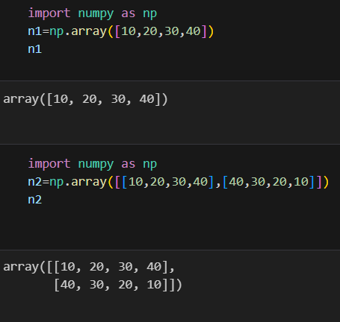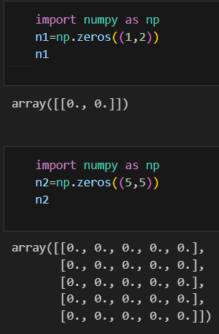

**Pandas**

Uses pandas for data manipulation and analysis through DataFrame and Series.

Functions like pd.read_csv(), df.head(), and df.describe() are used for reading, viewing, and summarizing data.

**IRIS Dataset**

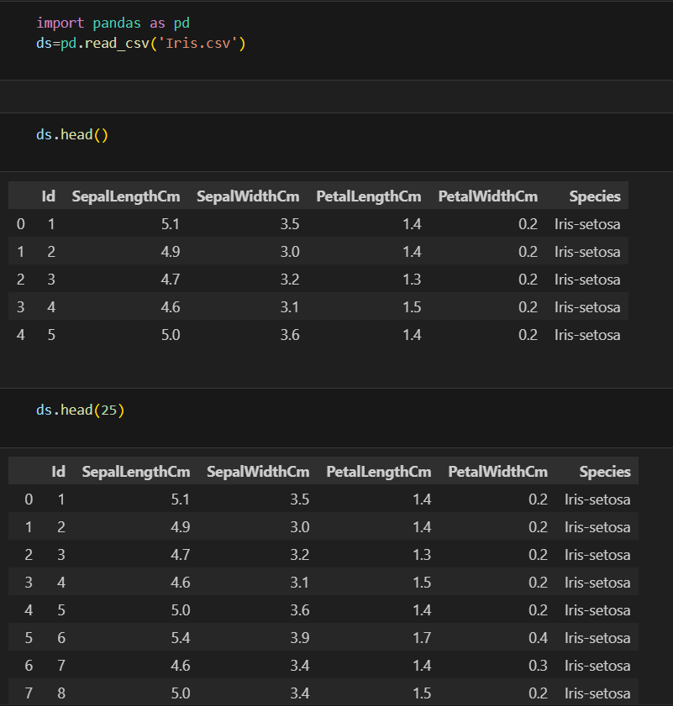

**Matplot and Seaborn**

Uses matplotlib.pyplot for visualizing data through plots (plt.plot(), plt.bar(), plt.scatter()).

Parameters like color, label, linewidth, and marker define chart appearance.

